Treyton Davis

CS-405

May 16, 2024

Module 2.3 Assignment

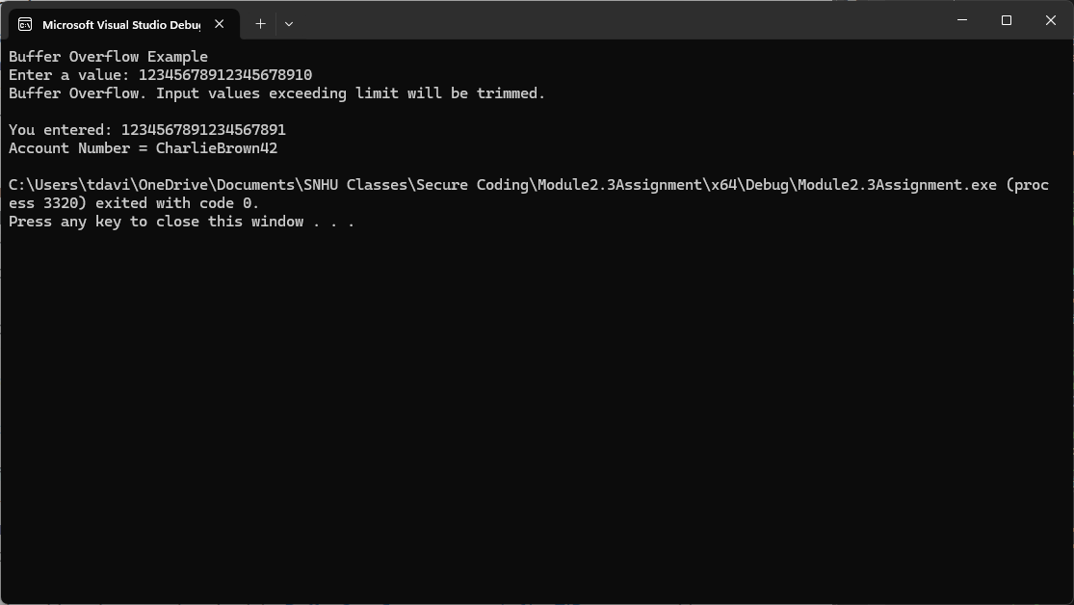

For this assignment, I added a variable named MAX_INPUT_LENGTH to allow the system administrators to change the amount of characters allowed in case they start to approach the max length as needed. After that, I added an if statement to check if cin was over or user the max limit. If it is, then the if statement will execute and alert the user of a buffer overflow. If it does not go over the limit, then it skips the if and prints what was entered.